HONORS CHEMISTRY • UNIT 4
Chemical Reactions
Write, balance, classify and predict the products of chemical reactions, then show only the particles that actually change.

TEACHER EDITION
Everything in a light-gray box or cell is an answer or model response. Teacher notes (misconceptions, demo ideas, discussion prompts, sources) appear in the heavy-bordered boxes labeled TEACHER NOTE. The pages follow the student packet, so they line up closely.

What we will learn
4.1 | Balancing equations & writing reactions
4.2 | Types of reactions
4.3 | Predicting products: synthesis, decomposition, combustion
4.4 | Predicting products: single replacement (activity series)
4.5 | Predicting products: double replacement (solubility rules)
4.6 | Net ionic equations
4.7 | Naming & writing formulas (review)

By the end of this unit I can…
• Balance equations using coefficients and explain why equations must be balanced.
• Translate between word equations and balanced symbol equations with state symbols.
• Classify a reaction as synthesis, decomposition, single replacement, double replacement or combustion.
• Predict the products of synthesis, decomposition and combustion reactions.
• Use the activity series to predict single replacement reactions and solubility rules to predict precipitates.
• Write complete, ionic and net ionic equations and identify spectator ions.
• Name and write formulas for ionic compounds, molecular compounds, acids and polyatomic ions.
TEACHER OVERVIEW
Numbering: the homework folder calls this “Unit 4 – Reactions” (topics 4.1–4.7). This packet uses the same numbers: Unit 4, topics 4.1–4.7, in the same order.
Answers are computed. Balanced equations, double-replacement products, solubility and net ionic equations in the key were generated by code (atoms and charges checked), then proofread.
Homework quirks fixed in the packet: HW 4.2 #5 is written 2La₂O₃ → 4Al + 3O₂ (typo; Al₂O₃ used) and #7 is 4C₄H₉O + 27O₂ (not a real compound; butanol, C₄H₁₀O, used). HW 4.5 #13 lists BaSO₄ as aqueous (it is insoluble); the key says no reaction. HW 4.4 lists many reactants as solids; the key uses the same states as the homework only where meaningful.
Misconceptions: changing subscripts to balance; forgetting diatomic elements (H₂, N₂, O₂, F₂, Cl₂, Br₂, I₂); writing weak electrolytes/solids/gases as ions in net ionic equations; assuming every double replacement “reacts” (no precipitate/gas/water = no reaction); mixing up the activity series direction (a metal replaces a LESS active metal’s ion).

4.1 | Balancing Chemical Equations & Writing Reactions Law of conservation of mass • coefficients • state symbols

BIG IDEA
Atoms are not created or destroyed in a chemical reaction, so every atom on the reactant side must appear on the product side. We balance by changing coefficients (the big numbers in front), never the subscripts.

Key vocabulary — write each definition in your own words
Term | Definition (your words) | Example / sketch
Reactant / product | Reactants are the starting substances (left of the arrow); products are the new substances formed (right). | H₂ + O₂ → H₂O
Coefficient vs subscript | A coefficient tells how many units of a substance take part; a subscript tells how many atoms are in one unit and can never be changed (it would change the substance). | 2H₂O: 2 is the coefficient, ₂ the subscript
Law of conservation of mass | Matter is neither created nor destroyed in a chemical reaction; the mass and the number of each kind of atom stay the same. | 4 H atoms in = 4 H atoms out
State symbols | (s) solid, (l) liquid, (g) gas, (aq) aqueous = dissolved in water. | NaCl(aq)

1. Why does a chemical equation need to be balanced? What does a balanced equation represent? (Think about a cooking recipe.)
Because of the law of conservation of mass: atoms can’t disappear or appear, so the same atoms must be on both sides. A balanced equation is like a recipe: it shows the exact ratio of particles (and moles) of each reactant needed and each product made, e.g. 2 H₂ + O₂ → 2 H₂O means 2 molecules (or moles) of hydrogen react with 1 of oxygen to make 2 of water.

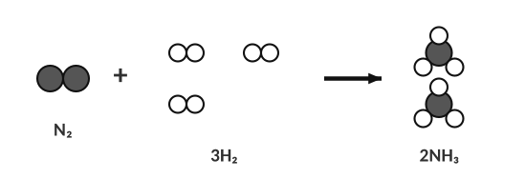
N₂ + 3H₂ → 2NH₃: 2 N and 6 H on each side.
HOW TO BALANCE (TRY THIS ORDER)
1. Write the correct formulas (diatomic elements: H₂, N₂, O₂, F₂, Cl₂, Br₂, I₂).
2. Make an atom tally for each side. Treat a polyatomic ion (PO₄, NO₃, SO₄ …) as one unit if it stays together.
3. Balance metals first, then non-metals, then H, then O last. Elements that appear in one compound on each side are easiest.
4. If you get a fraction, multiply everything by 2. Re-check every atom. Coefficients must be the lowest whole numbers.

WORKED EXAMPLE — A COMBUSTION
Balance: ___ C₂H₆ + ___ O₂ → ___ CO₂ + ___ H₂O

C: 2 on the left → put 2 in front of CO₂. H: 6 on the left → 3 H₂O. O on the right: 2(2) + 3 = 7 → needs 3½ O₂. Multiply all by 2: 2C₂H₆ + 7O₂ → 4CO₂ + 6H₂O ✓ C 4/4, H 12/12, O 14/14

Practice: balance each equation
Use the space under each equation for your atom tally (count each element on both sides) and your trial coefficients.
 | Balance each equation. Show your atom tally and work below it, then write the final balanced equation.
a. | ___ Na + ___ O₂ → ___ Na₂O  ANSWER: 4Na + O₂ → 2Na₂O
b. | ___ K + ___ B₂O₃ → ___ K₂O + ___ B  ANSWER: 6K + B₂O₃ → 3K₂O + 2B
c. | ___ H₃PO₄ + ___ KOH → ___ K₃PO₄ + ___ H₂O  ANSWER: H₃PO₄ + 3KOH → K₃PO₄ + 3H₂O
d. | ___ Al + ___ S₈ → ___ Al₂S₃  ANSWER: 16Al + 3S₈ → 8Al₂S₃
e. | ___ N₂ + ___ O₂ → ___ N₂O₅  ANSWER: 2N₂ + 5O₂ → 2N₂O₅
f. | ___ H₃PO₄ + ___ Mg(OH)₂ → ___ Mg₃(PO₄)₂ + ___ H₂O  ANSWER: 2H₃PO₄ + 3Mg(OH)₂ → Mg₃(PO₄)₂ + 6H₂O
g. | ___ NH₃ + ___ O₂ → ___ N₂ + ___ H₂O  ANSWER: 4NH₃ + 3O₂ → 2N₂ + 6H₂O
h. | ___ FeS₂ + ___ O₂ → ___ Fe₂O₃ + ___ SO₂  ANSWER: 4FeS₂ + 11O₂ → 2Fe₂O₃ + 8SO₂

2. Draw particle diagrams to balance H₂ + O₂ → H₂O. Draw the correct number of molecules on each side.
2 H₂ + O₂ → 2 H₂O (4 H and 2 O on each side)

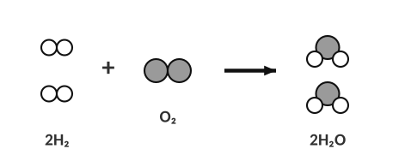
Answer
Writing equations from words
HELPFUL REMINDERS
• Diatomic elements are always written as molecules: H₂, N₂, O₂, F₂, Cl₂, Br₂, I₂.
• Use the ion charges to write correct formulas (criss-cross) and then balance.
• Add states: (s), (l), (g), (aq).

Polyatomic ion | Name | Polyatomic ion | Name
NH₄⁺ | ammonium | SO₄²⁻ | sulfate
NO₃⁻ | nitrate | CO₃²⁻ | carbonate
OH⁻ | hydroxide | PO₄³⁻ | phosphate
C₂H₃O₂⁻ | acetate | ClO₃⁻ | chlorate
MnO₄⁻ | permanganate | CN⁻ | cyanide

Reaction described in words | Balanced equation with states
Sodium metal reacts with chlorine gas to produce sodium chloride. | 2Na (s) + Cl₂ (g) → 2NaCl (s)
Aluminum metal reacts with aqueous copper(II) nitrate to produce aqueous aluminum nitrate and copper metal. | 2Al (s) + 3Cu(NO₃)₂ (aq) → 2Al(NO₃)₃ (aq) + 3Cu (s)
Aqueous nitric acid reacts with aqueous magnesium hydroxide to produce aqueous magnesium nitrate and liquid water. | 2HNO₃ (aq) + Mg(OH)₂ (aq) → Mg(NO₃)₂ (aq) + 2H₂O (l)
Propane gas (C₃H₈) reacts with oxygen gas to produce gaseous carbon dioxide and gaseous water. | C₃H₈ (g) + 5O₂ (g) → 3CO₂ (g) + 4H₂O (g)
Solid aluminum oxide decomposes into solid aluminum and oxygen gas. | 2Al₂O₃ (s) → 4Al (s) + 3O₂ (g)
Solid ammonium chloride decomposes into gaseous nitrogen trihydride and gaseous hydrochloric acid. | NH₄Cl (s) → NH₃ (g) + HCl (g)
Aqueous lead(II) nitrate and aqueous potassium iodide react to produce solid lead(II) iodide and aqueous potassium nitrate. | Pb(NO₃)₂ (aq) + 2KI (aq) → PbI₂ (s) + 2KNO₃ (aq)

Turn each equation into a word equation:
Equation | Word equation
Na₂O(s) + H₂O(l) → 2NaOH(aq) | Solid sodium oxide reacts with liquid water to produce aqueous sodium hydroxide.
CS₂(l) + 3O₂(g) → CO₂(g) + 2SO₂(g) | Liquid carbon disulfide reacts with oxygen gas to produce carbon dioxide gas and sulfur dioxide gas.
K(s) + CuNO₃(aq) → KNO₃(aq) + Cu(s) | Solid potassium reacts with aqueous copper(I) nitrate to produce aqueous potassium nitrate and solid copper.
2Li(s) + 2H₂O(l) → 2LiOH(aq) + H₂(g) | Solid lithium reacts with liquid water to produce aqueous lithium hydroxide and hydrogen gas.

TEACHER NOTE
Note: the K + CuNO₃ line is as written in the homework (copper(I) nitrate); it is balanced as K + CuNO₃ → KNO₃ + Cu.

4.2 | Types of Reactions Six patterns

Type | General pattern | Clue | Example
Synthesis | A + B → AB | 2 or more reactants, 1 product | 2Na + Cl₂ → 2NaCl
Decomposition | AB → A + B | 1 reactant (a binary compound), breaks into its elements | 2H₂O → 2H₂ + O₂
Single replacement | A + BC → AC + B | element + compound → new element + new compound | Zn + CuSO₄ → ZnSO₄ + Cu
Double replacement | AB + CD → AD + CB | two compounds swap partners (precipitate or gas) | AgNO₃ + NaCl → AgCl + NaNO₃
Neutralization | HA + MOH → MA + H₂O | an acid plus a base makes a salt and water | HCl + NaOH → NaCl + H₂O
Combustion | CₓHᵧ + O₂ → CO₂ + H₂O | hydrocarbon (or similar) + O₂, heat and light | CH₄ + 2O₂ → CO₂ + 2H₂O

Acids and bases: how do I tell them apart?
Key terms — write each definition in your own words
Term | Definition (your words) | Example / sketch
Acid | A compound that releases hydrogen ions (H⁺) in water. The formula usually starts with H. | HCl, H₂SO₄, HNO₃, HC₂H₃O₂
Base | A compound that releases hydroxide ions (OH⁻) in water. The formula usually ends with OH (metal + OH). | NaOH, Ca(OH)₂, KOH
Salt | An ionic compound made of the metal from the base and the non-metal part of the acid. | NaCl from HCl + NaOH

NEUTRALIZATION
An acid and a base swap partners: the H⁺ from the acid joins the OH⁻ from the base to make water, and the leftover ions form a salt. acid + base → salt + water

Predict the salt and water
Reactants | Balanced equation | Name of the salt
HCl + NaOH | HCl + NaOH → NaCl + H₂O | sodium chloride
H₂SO₄ + KOH | H₂SO₄ + 2KOH → K₂SO₄ + 2H₂O | potassium sulfate
HNO₃ + Ca(OH)₂ | 2HNO₃ + Ca(OH)₂ → Ca(NO₃)₂ + 2H₂O | calcium nitrate
HBr + Al(OH)₃ | 3HBr + Al(OH)₃ → AlBr₃ + 3H₂O | aluminum bromide

TEACHER NOTE
Neutralization is really a double replacement that makes water, so students may also call it that; accept either on early quizzes but the packet asks for “neutralization” whenever an acid and a base react. Classic demos: universal indicator in HCl then add NaOH; or magnesium hydroxide suspension dropped into dilute HCl with indicator.

Classify each reaction
# | Reaction | Type
1 | C₅H₁₂ + 8O₂ → 5CO₂ + 6H₂O | combustion
2 | 2K₃PO₄ + 3BaCl₂ → Ba₃(PO₄)₂ + 6KCl | double replacement
3 | 2Al(OH)₃ + 3H₂SO₄ → Al₂(SO₄)₃ + 6H₂O | neutralization
4 | 2AgNO₃ + Na₂CO₃ → Ag₂CO₃ + 2NaNO₃ | double replacement
5 | 2Al₂O₃ → 4Al + 3O₂ | decomposition
6 | 2Al + 6HCl → 3H₂ + 2AlCl₃ | single replacement
7 | C₄H₁₀O + 6O₂ → 4CO₂ + 5H₂O | combustion
8 | 3HBr + Al(OH)₃ → 3H₂O + AlBr₃ | neutralization
9 | 2NH₃ + H₂SO₄ → (NH₄)₂SO₄ | synthesis
10 | 2HgO → 2Hg + O₂ | decomposition
11 | Na₂O + H₂O → 2NaOH | synthesis
12 | Cu + 2AgNO₃ → 2Ag + Cu(NO₃)₂ | single replacement

TEACHER NOTE — CORRECTIONS
Equations 3 and 5 have been corrected from the homework (Al(OH)₃ + H₂SO₄ gives 6 H₂O when balanced; Al₂O₃ replaces the typo La₂O₃) and 7 uses butanol in place of the non-existent C₄H₉O. In #9, NH₃ + H₂SO₄ is a synthesis as written (a base without OH⁻ in its formula); mention it if students ask.

1. Which reaction type has the pattern AB → A + B?
A) synthesis B) decomposition C) single replacement D) combustion
2. HNO₃ + KOH → KNO₃ + H₂O is…
A) synthesis B) decomposition C) neutralization D) combustion
4.3 | Predicting Products: Synthesis, Decomposition & Combustion Reactants → products

PREDICTION RULES
Synthesis (two elements combine): a metal + non-metal makes an ionic compound. Use the group number to find each charge (Group 1 → 1+, Group 2 → 2+, Group 3 → 3+; Group 15 → 3−, Group 16 → 2−, Group 17 → 1−), then criss-cross the charges to write the formula (Mg²⁺ + O²⁻ → MgO). (If a problem combines two non-metals, the product’s formula will be given.)
Decomposition: a binary compound (two elements) breaks apart into its two pure elements (by electrolysis or strong heat). Remember the diatomic elements: H₂, N₂, O₂, F₂, Cl₂, Br₂, I₂.
Combustion: hydrocarbon (or an alcohol) + O₂ → CO₂ + H₂O (complete combustion).

Complete and balance
 | Reactants → | Balanced equation (products and coefficients) | Type
1 | Na + Cl₂ → | 2Na + Cl₂ → 2NaCl | synthesis
2 | Mg + O₂ → | 2Mg + O₂ → 2MgO | synthesis
3 | Al + S₈ → | 16Al + 3S₈ → 8Al₂S₃ | synthesis
4 | Li + N₂ → | 6Li + N₂ → 2Li₃N | synthesis
5 | NaCl → | 2NaCl → 2Na + Cl₂ | decomposition
6 | H₂O → | 2H₂O → 2H₂ + O₂ | decomposition
7 | Al₂O₃ → | 2Al₂O₃ → 4Al + 3O₂ | decomposition
8 | CH₄ + O₂ → | CH₄ + 2O₂ → CO₂ + 2H₂O | combustion
9 | C₂H₆ + O₂ → | 2C₂H₆ + 7O₂ → 4CO₂ + 6H₂O | combustion
10 | C₂H₄ + O₂ → | C₂H₄ + 3O₂ → 2CO₂ + 2H₂O | combustion

TEACHER NOTE
Items 1–3: students find charges from the group number and criss-cross (Na⁺Cl⁻, Mg²⁺O²⁻, Al³⁺S²⁻ → Al₂S₃). Item 4 (Li₃N) uses the same method with a 3− nitride ion. Non-metal + non-metal syntheses are left out because their products can’t be predicted from charges; if you include one, give the formula. Iron and other transition metals are left out of synthesis prediction because their charge isn’t fixed. Electrolysis of molten NaCl/Al₂O₃ is not a bench demo; show a video. Incomplete combustion (CO or C) can be mentioned but is not required.

1. Propane (C₃H₈) burns completely in oxygen. Which products form?
A) CO and H₂ B) CO₂ and H₂O C) C and H₂O D) C₃H₈ and O₂
LAB CORNER • Electrolysis of water

A power supply is connected to two electrodes in water. Gas collects in two inverted tubes in a volume ratio of 2 : 1.
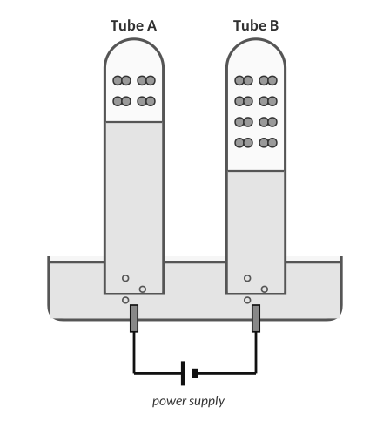
Each pair of dots is one gas molecule. Both tubes were filled by the same power supply for the same time.
2. Look at the amounts of gas collected. (a) Which tube holds hydrogen and which holds oxygen? Explain how you decided. (b) Write the balanced decomposition equation for water.
(a) Tube B has twice as much gas as Tube A, so Tube B is hydrogen and Tube A is oxygen. The balanced equation is 2H₂O (l) → 2H₂ (g) + O₂ (g); the coefficients 2 : 1 mean twice as many molecules of H₂ as O₂, and equal numbers of gas molecules take up equal volumes.
(b) 2H₂O (l) → 2H₂ (g) + O₂ (g)

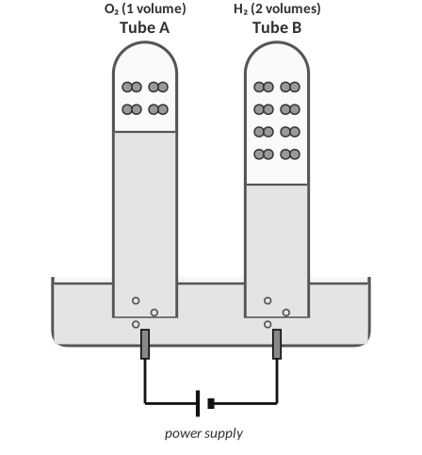
Answer key: gases labeled.
4.4 | Single Replacement & the Activity Series A more active element replaces a less active one

BIG IDEA
In a single replacement reaction a free element swaps places with an element in a compound. It only works if the free element is more active (more eager to lose or gain electrons) than the one it replaces.

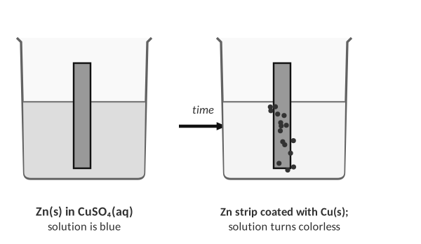
Zinc is more active than copper: Zn + CuSO₄ → ZnSO₄ + Cu.
Activity series | Most active → least active
Metals | Li, K, Ba, Sr, Ca, Na, Mg, Al, Zn, Fe, Ni, Pb, (H), Cu, Ag, Au
Halogens | F₂ > Cl₂ > Br₂ > I₂
Reacts with cold water? | Li, K, Ba, Sr, Ca, Na → metal hydroxide + H₂ (2Na + 2H₂O → 2NaOH + H₂); metals below Ca, Na do not.

1. Explain in words how to decide whether a single replacement reaction will happen.
Find the free element and the element it would replace in the compound in the activity series. If the free element is higher (more active) than the element in the compound, it replaces it; if it is lower, there is no reaction (NR). For halogens, compare halogens with the anion.

2. Write the balanced equation for Zn + CuSO₄ and tell which metal is more active and how you know.
Zn (s) + CuSO₄ (aq) → ZnSO₄ (aq) + Cu (s). Zinc is more active than copper: it replaced the copper ion in the compound, and the copper metal came out of solution.

Predict the products (write NR if no reaction)
 | Reactants | Products (balanced) or NR
1 | Li + BaCl₂ → | 2Li + BaCl₂ → 2LiCl + Ba
2 | Li + CaS → | 2Li + CaS → Li₂S + Ca
3 | K + BaCl₂ → | 2K + BaCl₂ → 2KCl + Ba
4 | Ba + NaF → | Ba + 2NaF → BaF₂ + 2Na
5 | Na + MgCl₂ → | 2Na + MgCl₂ → 2NaCl + Mg
6 | F₂ + NaCl → | F₂ + 2NaCl → 2NaF + Cl₂
7 | Cl₂ + NaF → | NR (Cl₂ is less active than F₂)
8 | Cu + FeSO₄ → | NR (Cu is less active than Fe)
9 | Na + H₂O → | 2Na + 2H₂O → 2NaOH + H₂
10 | Ag + H₂O → | NR (Ag is far below Na in the series)

TEACHER NOTE
The homework lists several of these reactants as (s), (aq) etc. inconsistently (e.g., BaCl₂(s)); the packet leaves states out for the prediction task. Compare Na and Mg carefully: Na is more active than Mg in the standard series, so Na + MgCl₂ does react.

3. Which will NOT react?
A) Zn + CuSO₄ B) Mg + FeCl₂ C) Cu + ZnCl₂ D) Cl₂ + KBr
4.5 | Double Replacement & Solubility Rules Swap partners • precipitate, water or gas

BIG IDEA
In a double replacement reaction two compounds exchange partners: AB + CD → AD + CB. In water the reaction only “happens” if one new compound is a solid (precipitate), water or a gas; otherwise the ions just stay mixed (no reaction).

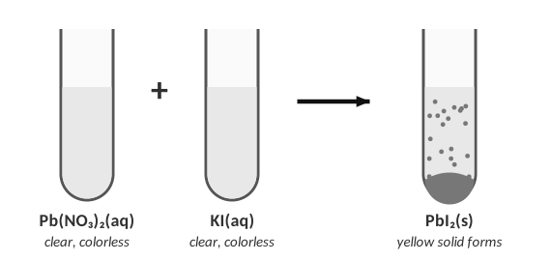
Two clear solutions form a solid precipitate (colored yellow in real life).
Solubility rules (water) | Soluble (aq) … | … except
Group 1 ions (Li⁺, Na⁺, K⁺) and NH₄⁺ | always soluble | none
Nitrates (NO₃⁻), acetates (C₂H₃O₂⁻), chlorates | always soluble | none
Chlorides, bromides, iodides | soluble | Ag⁺, Pb²⁺
Sulfates | soluble | Ba²⁺, Sr²⁺, Pb²⁺, Ca²⁺(slightly), Ag⁺
Hydroxides, carbonates, phosphates, sulfides, sulfites | insoluble (s) | Group 1, NH₄⁺ (and Ba²⁺, Sr²⁺, Ca²⁺ hydroxides)

STEPS
1. Swap the cations. 2. Write each new formula using ion charges (criss-cross). 3. Balance. 4. Use the solubility rules to label (s) or (aq). 5. If both products are aqueous: no reaction.

# | Reactants | Products (balanced, with states) or NR
11 | BaCl₂ + H₃PO₄ (aq) → | 3BaCl₂ (aq) + 2H₃PO₄ (aq) → Ba₃(PO₄)₂ (s) + 6HCl (aq)
12 | K₂SO₄ + MgF₂ (aq) → | NR (no solid, gas or water forms)
13 | AlCl₃ + BaSO₄ (aq) → | NR (no solid, gas or water forms)
14 | Li₂S + AgNO₃ (aq) → | Li₂S (aq) + 2AgNO₃ (aq) → 2LiNO₃ (aq) + Ag₂S (s)
15 | BaCl₂ + Na₂CO₃ (aq) → | BaCl₂ (aq) + Na₂CO₃ (aq) → BaCO₃ (s) + 2NaCl (aq)
16 | Al₂(SO₄)₃ + Na₃PO₄ (aq) → | Al₂(SO₄)₃ (aq) + 2Na₃PO₄ (aq) → 2AlPO₄ (s) + 3Na₂SO₄ (aq)
17 | Na₂SO₄ + NH₄I (aq) → | NR (no solid, gas or water forms)
18 | Li₃PO₄ + BaCl₂ (aq) → | 2Li₃PO₄ (aq) + 3BaCl₂ (aq) → 6LiCl (aq) + Ba₃(PO₄)₂ (s)
19 | AlBr₃ + H₃PO₄ (aq) → | AlBr₃ (aq) + H₃PO₄ (aq) → AlPO₄ (s) + 3HBr (aq)
20 | Zn(NO₃)₂ + Ba(OH)₂ (aq) → | Zn(NO₃)₂ (aq) + Ba(OH)₂ (aq) → Zn(OH)₂ (s) + Ba(NO₃)₂ (aq)

TEACHER NOTE
The homework numbering continues from #11. #13 lists BaSO₄ as a reactant (aq); BaSO₄ is insoluble, so the key calls it NR. Weak acids/gases (H₂CO₃ → H₂O + CO₂, NH₄OH → NH₃) can be mentioned as extra ‘driving forces’ but are not needed for the exam.

1. Which pair gives a precipitate?
A) NaCl + KNO₃ B) Pb(NO₃)₂ + KI C) NH₄Cl + NaNO₃ D) K₂SO₄ + NaCl
2. What is the precipitate when AgNO₃(aq) and NaCl(aq) are mixed?
A) NaNO₃ B) AgCl C) AgNO₃ D) no precipitate
4.6 | Net Ionic Equations Show only the particles that change

Key terms
Term | Definition (your words) | Example / sketch
Net ionic equation | An equation that shows only the particles that actually change in a reaction; spectator ions are left out. | Ag⁺(aq) + Cl⁻(aq) → AgCl(s)
Spectator ion | An ion that is present before and after the reaction but doesn’t take part (it stays dissolved). | Na⁺ and NO₃⁻ in the example

HOW TO WRITE ONE
1. Balanced molecular equation with states.
2. Split soluble ionic compounds (aq) into ions. Keep solids (s), liquids (l), gases (g) and weak electrolytes together.
3. Cancel the ions that appear unchanged on both sides (spectators).
4. Write what is left; check atoms AND charge.

A student dissolves sodium carbonate and magnesium nitrate in water. The diagrams show the beaker before and after the reaction.
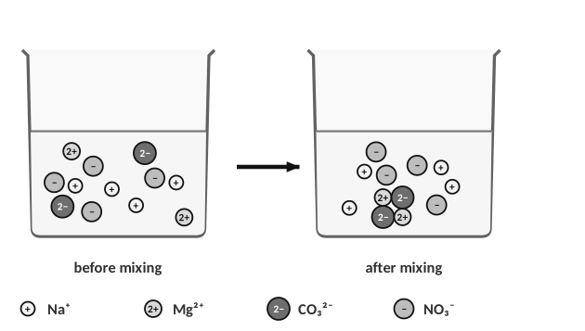
1. (a) Write the balanced equation. (b) Which ions react and which are spectators? (c) Justify with the diagram. (d) Write the net ionic equation.
(a) Na₂CO₃ (aq) + Mg(NO₃)₂ (aq) → 2NaNO₃ (aq) + MgCO₃ (s)
(b) Reacting: Mg²⁺ and CO₃²⁻. Spectators: Na⁺ and NO₃⁻.
(c) In the diagram, the Na⁺ and NO₃⁻ ions are still dissolved and unchanged after the reaction, while the Mg²⁺ and CO₃²⁻ ions are gone from the solution and appear as the solid MgCO₃ at the bottom.
(d) CO₃²− (aq) + Mg²⁺ (aq) → MgCO₃ (s)

Write the net ionic equation
 | Reaction | Net ionic equation
a | SrBr₂(aq) + K₂SO₄(aq) → SrSO₄(s) + 2KBr(aq) | Sr²⁺ (aq) + SO₄²− (aq) → SrSO₄ (s)
b | 3Ca(OH)₂(aq) + 2FeCl₃(aq) → 3CaCl₂(aq) + 2Fe(OH)₃(s) | 3OH− (aq) + Fe³⁺ (aq) → Fe(OH)₃ (s)
c | 2AgOH(s) + H₂CO₃(aq) → Ag₂CO₃(s) + 2H₂O(l) | 2AgOH(s) + H₂CO₃(aq) → Ag₂CO₃(s) + 2H₂O(l) (no spectators: every species is a solid, a liquid or a weak acid, so nothing is split)
d | Fe(s) + NiCl₃(aq) → FeCl₃(aq) + Ni(s) | Fe(s) + Ni³⁺(aq) → Fe³⁺(aq) + Ni(s) (Cl⁻ is the spectator)
e | Sodium sulfide(aq) + iron(II) nitrate(aq) → | Na₂S (aq) + Fe(NO₃)₂ (aq) → 2NaNO₃ (aq) + FeS (s)  Net: S²− (aq) + Fe²⁺ (aq) → FeS (s)

TEACHER NOTE
Check (b): Ca(OH)₂ is treated as soluble here (the homework equation lists it as aqueous). Net ionic: Fe³⁺(aq) + 3OH⁻(aq) → Fe(OH)₃(s). In (d) the charges balance: +3 −3 = 0 on the left, neutral solid on the right. Common errors: splitting the solid, forgetting to reduce the coefficients, losing charge balance.

2. Spectator ions are…
A) ions that form the precipitate
B) ions that stay dissolved and unchanged
C) ions that gain electrons
D) ions in the solid

4.7 | Naming & Writing Formulas (Review) Ionic • molecular • acids

Type | Rule | Example
Ionic (metal + non-metal) | cation name + anion name (-ide); transition metals get a Roman numeral for the charge | Li₂S = lithium sulfide; FeCl₃ = iron(III) chloride
With polyatomic ion | name of the cation + name of the polyatomic ion (no change) | Mg(C₂H₃O₂)₂ = magnesium acetate
Molecular (2 non-metals) | prefixes: mono, di, tri, tetra, penta, hexa, hepta, octa; no ‘mono’ on the first element | N₂O₃ = dinitrogen trioxide
Binary acid | hydro- + root + -ic acid | HCN = hydrocyanic acid; HCl = hydrochloric acid
Oxyacid | -ate ion → -ic acid; -ite ion → -ous acid | HClO₃ = chloric acid (from chlorate)

 | Given | Name or formula
1 | Li₂S | lithium sulfide
2 | beryllium phosphide | Be₃P₂
3 | Be(OH)₂ | beryllium hydroxide
4 | P₂Br₄ | diphosphorus tetrabromide
5 | SF₆ | sulfur hexafluoride
6 | magnesium acetate | Mg(C₂H₃O₂)₂
7 | diboron tetrahydride | B₂H₄
8 | dinitrogen trioxide | N₂O₃
9 | hydrocyanic acid | HCN
10 | lithium iodide | LiI
11 | KMnO₄ | potassium permanganate
12 | HClO₃ | chloric acid

1. Which is the correct name for N₂O₃?
A) nitrogen oxide B) dinitrogen trioxide C) nitrogen(III) oxide D) dinitrogen oxide
PRACTICE
Extra Practice — Unit 4
Show your work.

A. Balance
 | Balance each equation (show your atom tally below it)
a | Al + HCl → AlCl₃ + H₂  ANSWER: 2Al + 6HCl → 2AlCl₃ + 3H₂
b | Fe + O₂ → Fe₂O₃  ANSWER: 4Fe + 3O₂ → 2Fe₂O₃
c | C₄H₁₀ + O₂ → CO₂ + H₂O  ANSWER: 2C₄H₁₀ + 13O₂ → 8CO₂ + 10H₂O
d | Ca(OH)₂ + H₃PO₄ → Ca₃(PO₄)₂ + H₂O  ANSWER: 3Ca(OH)₂ + 2H₃PO₄ → Ca₃(PO₄)₂ + 6H₂O

B. Classify and predict
Reactants | Balanced products | Type
Mg + O₂ | 2Mg + O₂ → 2MgO | synthesis
HgO (heat) | 2HgO → 2Hg + O₂ | decomposition
C₃H₈ + O₂ | C₃H₈ + 5O₂ → 3CO₂ + 4H₂O | combustion
Zn + HCl | Zn + 2HCl → ZnCl₂ + H₂ | single replacement
AgNO₃ + CaCl₂ | 2AgNO₃ + CaCl₂ → 2AgCl + Ca(NO₃)₂ | double replacement
HCl + Ca(OH)₂ | 2HCl + Ca(OH)₂ → CaCl₂ + 2H₂O | neutralization

C. Precipitation lab data
A student mixes pairs of 0.1 M solutions and records whether a solid forms. Predict the result and write the net ionic equation for the ones that react.
Solutions mixed | Precipitate? | Net ionic equation
NaCl + AgNO₃ | yes | Cl− (aq) + Ag⁺ (aq) → AgCl (s)
KI + Pb(NO₃)₂ | yes | 2I− (aq) + Pb²⁺ (aq) → PbI₂ (s)
NaOH + CuSO₄ | yes | 2OH− (aq) + Cu²⁺ (aq) → Cu(OH)₂ (s)
KNO₃ + NaCl | no | no reaction
BaCl₂ + K₂SO₄ | yes | Ba²⁺ (aq) + SO₄²− (aq) → BaSO₄ (s)

D. Think
1. A student balances H₂ + O₂ → H₂O by changing it to H₂ + O₂ → H₂O₂. Explain what is wrong with this method.
Changing a subscript changes the substance (hydrogen peroxide is not water); only coefficients may be changed: 2H₂ + O₂ → 2H₂O.

2. Explain why no reaction occurs when NaCl(aq) and KNO₃(aq) are mixed.
All four ions (Na⁺, Cl⁻, K⁺, NO₃⁻) form soluble compounds; no solid, gas or water forms, so the ions just stay mixed. All ions are spectators.

3. Which is a correct net ionic equation for AgNO₃ + NaCl?
A) AgNO₃ → Ag⁺ + NO₃⁻ B) Ag⁺ + Cl⁻ → AgCl(s) C) Na⁺ + NO₃⁻ → NaNO₃ D) Ag + Cl → AgCl
4. Which reaction type is: 2Mg + O₂ → 2MgO?
A) decomposition B) synthesis C) single replacement D) double replacement
Unit 4 review
5. Describe the steps for predicting the products of a reaction in each of the six reaction types.
Synthesis: join the elements (use charges). Decomposition: split a binary compound into its elements. Neutralization: acid + base → salt + water. Combustion: CO₂ + H₂O. Single replacement: use the activity series (more active replaces less active). Double replacement: swap partners; check for precipitate with solubility rules; then balance.

6. Explain the difference between a balanced equation, a complete ionic equation and a net ionic equation.
Balanced: all species as formulas. Complete ionic: aqueous strong electrolytes written as ions. Net ionic: spectators removed, leaving only the particles that change.

Sources & further reading
• PhET – Balancing Chemical Equations simulation (University of Colorado Boulder) — https://phet.colorado.edu/en/simulations/balancing-chemical-equations
• LibreTexts – 11.08 Activity Series (CK-12) — https://chem.libretexts.org/Bookshelves/Introductory_Chemistry/Introductory_Chemistry_(CK-12)/11:_Chemical_Reactions/11.08:_Activity_Series
• LibreTexts – Types of Chemical Reactions: Single and Double Replacement (Ball) — https://chem.libretexts.org/Bookshelves/Introductory_Chemistry/Beginning_Chemistry_(Ball)/04%3A_Chemical_Reactions_and_Equations/4.03%3A_Types_of_Chemical_Reactions_-_Single_and_Double_Replacement_Reactions
• LibreTexts – Single Replacement Reactions and Batteries (lab) — https://chem.libretexts.org/Ancillary_Materials/Laboratory_Experiments/Wet_Lab_Experiments/General_Chemistry_Labs/Online_Chemistry_Lab_Manual/Chem₉_Experiments/09:_Single_Replacement_Reactions_and_Batteries_(Experiment)

